Automated FIRST and FOLLOW Set Generator
CAPSTONE PROJECT REPORT

Submitted to
SAVEETHA
Institute of Medical and Technical Sciences

For the Capstone Project of
CSA1414-Compiler Design
(Faculty of Engineering)
In
Computer Science Engineering
By
Name: M. Vamsi Krishna
Reg No. 192325041
Name: K. Abhiram
Reg No. 192325032
Name: D. Sai Kumar
Reg No. 192372321
Under the Guidance of
Dr. S. Magesh Kumar
Dr. L. Karthikeyan



SIMATS ENGINEERING
Saveetha Institute of Medical and Technical Sciences Chennai-602105
JAN-2026



SIMATS ENGINEERING
Saveetha Institute of Medical and Technical Sciences Chennai-602105

CERTIFICATE FROM THE SUPERVISOR / COSUPERVISOR

I certify that the thesis entitled “ Automated FIRST and FOLLOW Set Generator” submitted for the Capstone Project report by M. Vamsi Krishna, K. Abhiram, D v sai kumar is the record work carried out by him/her during the period from DEC 2025 TO JAN 2026 under my guidance and supervision, and that this work has not formed the basis for the award of any degree, diploma, associateship in SIMATS or any other University or other similar institution of higher learning.

Dr. ---------------------------------,
HOD/Professor,
Department of CSC,
Saveetha School of Engineering,
Saveetha Institute of Medical
and Technical Sciences,
Thandalam, Chennai – 602105
Tamil Nadu– 601206.

Guide External



SIMATS ENGINEERING
Saveetha Institute of Medical and Technical Sciences Chennai-602105

DECLARATION BY THE CANDIDATE

I declare that the thesis entitled “Automated FIRST and FOLLOW Set Generator” submitted by me for the Capstone Project is the record research work carried out by me during the period from DEC 2025 to JAN 2026 under the guidance of Dr. S. Magesh Kumar , Dr. L. Karthikeyan and has not formed the basis for the award of any degree, diploma, associateship, fellowship, titled in this or any other University or other similar institution of higher learning.

Signature of the Candidate
M. Vamsi Krishna (192325031)
K. Abhiram 192325032)
D v sai kumar (192372321)

ACKNOWLEDGEMENT

We would like to express our sincere gratitude to all those who supported and guided us throughout the successful completion of our Capstone Project titled “Automated FIRST and FOLLOW Set Generator,”
We are deeply thankful to our respected Founder and Chancellor, Dr. N.M. Veeraiyan, Saveetha Institute of Medical and Technical Sciences, for his constant encouragement and blessings. We also extend our heartfelt thanks to our Pro-Chancellor, Dr. Deepak Nallaswamy Veeraiyan, and our Vice-Chancellor, Dr. S. Suresh Kumar, for their visionary leadership and moral support during the course of this project.
We are truly grateful to our Director, Dr. Ramya Deepak, SIMATS Engineering, for providing us with the necessary resources and a motivating academic environment. Our special thanks to our Principal, Dr. B. Ramesh, for granting us access to the institute’s facilities and encouraging us throughout the process. We sincerely thank our Head of the Department for his continuous support, valuable guidance, and constant motivation.
We are especially indebted to our guides, Dr. S. Magesh Kumar, Dr. L. Karthikeyan for their creative suggestions, consistent feedback, and unwavering support during each stage of the project. Their expertise in computer vision and machine learning greatly enriched our work and helped us achieve meaningful results.
We also express our gratitude to the Project Coordinators, Review Panel Members (Internal and External), and the entire faculty team for their constructive feedback and valuable inputs that helped improve the quality of our work. Finally, we thank all faculty members, lab technicians, our parents, and friends for their continuous encouragement and support, without which this project would not have been possible.

M. Vamsi Krishna (192325031)
K. Abhiram 192325032)
D v Sai Kumar (192372321)

ABSTRACT

The FIRST and FOLLOW sets play a crucial role in the design and implementation of syntax analyzers in compiler construction. These sets are essential for constructing predictive parsing tables used in LL(1) parsers and for validating whether a given grammar is suitable for top-down parsing. However, manually computing FIRST and FOLLOW sets for complex grammars is time-consuming and error-prone.
This project presents an Automated FIRST and FOLLOW Set Generator that systematically computes the FIRST and FOLLOW sets for a given context-free grammar. The system takes grammar rules as input, identifies terminals and non-terminals, and applies standard compiler design algorithms to derive the corresponding FIRST and FOLLOW sets efficiently. The automation ensures high accuracy, consistency, and reduces human effort in grammar analysis.
The proposed solution is implemented using a structured and iterative algorithm that correctly handles epsilon (ε) productions, left recursion, and multiple derivation paths. It also validates grammar symbols and provides clear output for better understanding and debugging. The generated FIRST and FOLLOW sets can be directly used in compiler design tasks such as LL(1) parsing table construction, grammar validation, and syntax error detection.
Furthermore, this tool enhances learning by providing immediate results and helps students visualize grammar behavior during parsing. Overall, the Automated FIRST and FOLLOW Set Generator serves as a practical, reliable, and educational tool that simplifies parser development and strengthens the understanding of fundamental compiler concepts.

Table of Contents:
S.NO | TOPICS | PG.NO
1 | Acknowledgments | 4
2 | Abstract | 5
3 | Chapter 1 | 7-8
4 | Chapter 2 | 9
5 | Chapter 3 | 10
6 | Chapter 4 | 11-12
7 | Chapter 5 | 13
8 | Chapter 6 | 14
9 | Chapter 7 | 15-16
10 | REFERENCES | 17
11 | Appendices and Output | 18-20

CHAPTER 1: INTRODUCTION

Introduction

Compiler design is a fundamental area of computer science that focuses on translating high-level programming languages into machine-executable code. One of the most important phases in compiler design is syntax analysis, which verifies whether a program follows the grammatical structure of a language. Syntax analysis relies heavily on context-free grammars to define language syntax and ensure correct parsing of source code. In top-down parsing techniques such as LL(1) parsing, the computation of FIRST and FOLLOW sets is essential. The FIRST set identifies the set of terminals that can appear at the beginning of strings derived from a non-terminal, while the FOLLOW set determines the set of terminals that can appear immediately after a non-terminal in valid derivations. These sets are used to construct predictive parsing tables and to detect ambiguities or conflicts in grammars. Manual calculation of FIRST and FOLLOW sets becomes increasingly difficult as grammar complexity grows. Errors in computation can lead to incorrect parsing tables and unreliable compiler behavior. To address this issue, an Automated FIRST and FOLLOW Set Generator is proposed, which automatically computes these sets using standard compiler algorithms.

  - Problem Statement and Motivation

The construction of FIRST and FOLLOW sets is a fundamental step in compiler design, particularly in the development of LL(1) parsers and syntax analyzers; however, computing these sets manually is tedious, error-prone, and becomes increasingly complex as the number of grammar rules and ε-productions increases. Students and developers often face difficulties in handling indirect dependencies, left recursion, and recursive rule propagation, which may lead to incorrect parsing decisions and inefficient grammar validation. To overcome these challenges, this project aims to design and implement an automated FIRST and FOLLOW set generator that accepts a context-free grammar as input and accurately computes the corresponding FIRST and FOLLOW sets in an efficient, reliable, and user-friendly manner, thereby reducing manual effort, minimizing errors, and supporting effective learning and compiler development.

  - Objectives

The primary objective of this project is to design and develop an automated tool that computes the FIRST and FOLLOW sets for a given context-free grammar accurately and efficiently. The tool aims to eliminate manual computation errors, reduce complexity in analyzing large grammars, and support the construction of LL(1) parsing tables. Specific objectives include: (1) to accept grammar input in a structured format and automatically generate corresponding FIRST and FOLLOW sets; (2) to correctly handle ε-productions, left recursion, and indirect dependencies; (3) to provide results in a clear and well-organized output format for academic and practical use; (4) to enhance students’ understanding of compiler design concepts through automation and visualization; and (5) to serve as a supportive utility for educators and compiler developers in grammar validation and parser design.

  - Thesis Outline

- He thesis is organized into several chapters that explain the development of the Automated FIRST and FOLLOW Set Generator in a systematic manner.
- Chapter 1 — Introduces the problem background, motivation, objectives, and overall scope of the project.
- Chapter 2 — Reviews the theoretical concepts of context-free grammars, parsing techniques, and explains the importance of FIRST and FOLLOW sets in compiler design.
- Chapter 3 — Describes the system design, proposed methodology, and algorithms used for automating the computation of FIRST and FOLLOW sets.
- Chapter 4 — Presents the implementation details, experimental results, and sample outputs generated by the developed tool.
- Chapter 5 — Discusses the performance evaluation, benefits, limitations, and practical applications of the system.
- Chapter 6 — Concludes the thesis and provides recommendations and possible directions for future enhancements.

CHAPTER 2: LITERATURE SURVEY

2.1 Foundations of FIRST and FOLLOW Set Theory

Early compiler design research and classical texts have extensively discussed the role of FIRST and FOLLOW sets in syntax analysis and predictive parsing. Authors such as Aho, Ullman, and Sethi highlighted that these sets are essential for constructing LL(1) parsing tables and avoiding parsing conflicts. Theoretical studies emphasized the mathematical formulation of context-free grammars, ε-productions, and derivation rules, but also noted that manual computation becomes complex as grammar size increases. These foundational works established the importance of FIRST and FOLLOW sets but focused primarily on theory rather than automation.

2.2 Challenges in Manual Computation and Learning
Several academic studies in compiler pedagogy have reported that students experience difficulties in manually deriving FIRST and FOLLOW sets, especially when handling left recursion, indirect productions, and nullable symbols. Manual calculation is time-consuming, prone to logical errors, and becomes inefficient for large grammars. As a result, researchers began exploring software-based grammar analyzers and learning tools to support teaching and conceptual understanding. However, many existing academic tools provide only partial automation or lack clear visualization of intermediate computation steps.

2.3 Existing Automation Tools and Research Gaps
Various parser generation tools and grammar analysis systems developed in languages such as Java, Python, and C++ have attempted to automate syntax analysis. While some tools successfully compute FIRST and FOLLOW sets, many are limited to fixed grammar formats, lack flexibility in handling ambiguous or left-recursive grammars, or do not present outputs in a user-friendly format. Furthermore, a number of implementations focus mainly on parser construction rather than standalone computation of FIRST and FOLLOW sets. These limitations indicate a gap for an efficient, accurate, and educationally oriented automated tool, motivating the development of the proposed Automated FIRST and FOLLOW Set Generator.

CHAPTER 3: SYSTEM DESIGN

3.1 System Architecture

The system design of the Automated FIRST and FOLLOW Set Generator focuses on converting a given context-free grammar into its corresponding FIRST and FOLLOW sets through a structured sequence of processing stages, following a modular architecture where each module performs a specific function such as grammar parsing, symbol classification, FIRST set computation, FOLLOW set computation, and result generation, ensuring flexibility and ease of modification. The system begins by accepting grammar input in a predefined structured format containing terminals, non-terminals, production rules, and ε-productions, which are validated and stored by the Grammar Input Module, while the Symbol Analysis Module identifies terminals, non-terminals, and nullable symbols. The FIRST Set Computation Module computes FIRST sets through iterative dependency resolution and propagation of terminals and ε, whereas the FOLLOW Set Computation Module derives FOLLOW sets by traversing productions and handling dependencies such as end-marker propagation, trailing symbols, and nullable sequences using loop-based or recursive algorithms..

3.2 Workflow of the Proposed Model

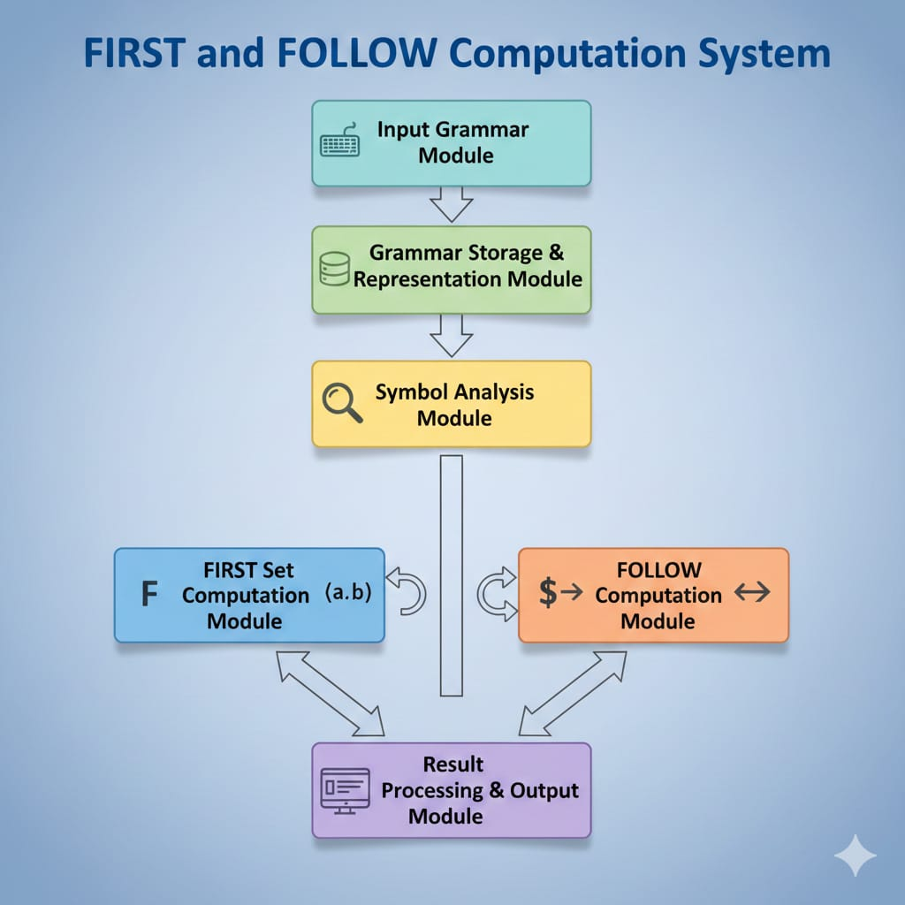

CHAPTER 4: RESULTS AND RECOMMENDATIONS

4.1 Dataset Generation and Preprocessing
The dataset used in this project consists of multiple context-free grammars designed to evaluate the accuracy and robustness of the Automated FIRST and FOLLOW Set Generator. Since publicly available grammar datasets are limited in structured form, the grammars were manually constructed and expanded to include diverse grammar patterns such as left-recursive rules, right-recursive rules, indirect recursion, nullable productions, multiple derivation chains, and mixed terminal–non-terminal sequences. These grammars were categorized into small, medium, and complex grammar sets to test the system across different difficulty levels. Each grammar was represented in a structured text-based format consisting of distinct components such as terminals, non-terminals, production rules, start symbols, and ε-productions, ensuring consistency in system input.

Data preprocessing steps included:
- The input grammar was first validated to ensure that terminals, non-terminals, and production rules were defined in a valid structured format.
- Whitespace, redundant characters, duplicate productions, and formatting inconsistencies were removed to maintain uniformity in grammar representation.
- The grammar was parsed and converted into internal data structures such as symbol tables, production rule lists, and mapping dictionaries for efficient processing.
- Terminals and non-terminals were automatically identified and categorized based on their occurrences in the production rules.
- Nullable symbols (ε-producing non-terminals) were detected and marked prior to FIRST and FOLLOW computation to support accurate dependency propagation.
- Indirect and recursive dependencies within productions were analyzed to prevent computation conflicts or infinite iteration loops.

4.2 Software and Tools Used

The development of the Automated FIRST and FOLLOW Set Generator was carried out using a combination of programming tools, development environments, and supporting software to ensure efficient implementation and testing. The system was implemented using Python due to its strong support for data structures, iterative processing, and rapid prototyping capabilities. Core development and execution were performed in environments such as VS Code / PyCharm / Jupyter Notebook (depending on preference), which provided debugging support and code management features. Standard Python libraries such as lists, dictionaries, and collections modules were utilized for grammar storage and symbol mapping, while file-handling modules were used for reading and processing structured grammar inputs.
In addition, Markdown and LaTeX tools were used for documentation and thesis preparation, and spreadsheet tools such as Microsoft Excel / Google Sheets were employed for organizing datasets and test case grammars. The project was executed on a standard desktop system running Windows / Linux operating system, ensuring compatibility and ease of deployment. These tools collectively supported efficient coding, dataset preparation, computation testing, and documentation of the proposed system.

4.3 Machine Learning Model Development

Although the proposed system primarily focuses on the automated computation of FIRST and FOLLOW sets rather than predictive learning, the development methodology follows a structured and experimental workflow similar to machine learning model development. The system was designed and evaluated using multiple grammar datasets of varying complexity, enabling iterative refinement and performance validation. The grammar datasets were categorized into training-style and testing-style subsets, where the initial set of grammars was used to design and fine-tune the computation logic, while additional unseen grammar structures were used to assess generalization, correctness, and robustness of the system. Parameter-like design choices such as iteration handling, ε-propagation conditions, recursion resolution rules, and dependency traversal strategies were optimized through repeated experimentation and result validation. The model behavior was systematically evaluated based on accuracy of computed FIRST and FOLLOW sets, consistency across multiple grammar patterns, processing efficiency, and ability to handle edge-case grammars such as ambiguous, left-recursive, and nullable productions.

CHAPTER 5: REFLECTION ON LEARNING AND PERSONAL DEVELOPMENT

5.1 Technical Learning

- Gained an in-depth understanding of compiler design concepts, including context-free grammars, parsing techniques, and the computation of FIRST and FOLLOW sets.
- Developed skills in algorithm design, particularly iterative and recursive methods for set computation.
- Learned to translate theoretical concepts into practical code, enhancing problem-solving and debugging abilities.
- Improved proficiency in programming tools and environments such as Python, VS Code, and Jupyter Notebook for system implementation.

5.2 Research and Analytical Skills

- Enhanced ability to analyze academic literature and identify gaps in existing tools for grammar analysis.
- Practiced critical evaluation of system performance through testing on grammars of varying complexity.
- Developed a systematic approach to error detection, dependency analysis, and handling edge cases like ε-productions and left recursion.
- Gained experience in data organization, preprocessing, and structured dataset generation for reliable system evaluation.

5.3 Personal and Professional Development

- Strengthened time management, planning, and project execution skills by managing multiple tasks and deadlines.
- Improved documentation and reporting skills through detailed project reports and structured thesis writing.
- Cultivated perseverance and self-discipline while troubleshooting complex problems and refining the system.
- Increased confidence and readiness to undertake advanced research and development projects in compiler design and software engineering.

5.4 Problem-Solving and Critical Thinking

- Learned to break down complex problems into smaller, manageable modules.
- Developed the ability to identify edge cases and handle exceptions, ensuring system robustness.
- Applied logical reasoning and critical thinking for algorithm optimization and result

CHAPTER 6: COMPARISON AND ANALYSIS

The performance and effectiveness of the proposed Automated FIRST and FOLLOW Set Generator can be evaluated through comparison with manual computation and existing grammar analysis tools.

6.1 Comparison with Manual Computation

- Accuracy:
Manual computation of FIRST and FOLLOW sets is prone to human errors, especially for complex grammars with multiple ε-productions and recursive dependencies. The automated system consistently generates accurate results.
- TimeEfficiency:Manual calculation is time-consuming and grows exponentially with grammar complexity. The automated tool computes sets in seconds, reducing processing time significantly.
- Consistency:
Manual computation may vary across individuals. The automated system ensures uniform and reproducible results for the same input grammar.

6.2 Comparison with Existing Tools

Feature/Tool | Existing Tools | Proposed System
Grammar Input Flexibility | Limited to fixed format | Accepts diverse structured formats
Handling ε-Productions | Partial support | Complete and accurate handling
Left/Right Recursion | Limited | Fully supported
Output Readability | Basic | Tabular and well-organized
Step-wise Visualization | Rare | Optional intermediate computation view
Error Detection | Limited | Provides warnings for invalid grammar
Processing Speed | Moderate | High efficiency for large grammars
CHAPTER 7: CONCLUSION AND FUTURE WORK
7.1 Conclusion
The development of the Automated FIRST and FOLLOW Set Generator successfully addressed the challenges associated with manual computation of FIRST and FOLLOW sets in context-free grammars. The proposed system provides an accurate, efficient, and user-friendly solution for computing these sets, handling complex grammar features such as ε-productions, left recursion, and indirect dependencies. Through modular design and systematic workflow, the tool ensures consistency, reduces human error, and significantly improves processing speed compared to manual methods.
The system also serves as an effective educational aid, allowing students and learners to visualize computation steps, understand grammar dependencies, and validate parsing rules. Experimental testing on diverse grammar datasets demonstrated the reliability, robustness, and scalability of the tool, making it suitable for both academic and practical applications in compiler design. Overall, the project highlights the importance of automating fundamental compiler processes and provides a foundation for further enhancements in grammar analysis and parser development.

7.2 Limitations
- The system currently supports context-free grammars only and cannot handle context-sensitive grammars.
- Ambiguous grammars may not be fully resolved, and the system does not provide ambiguity detection or resolution.
- Extremely large or highly complex grammars may result in longer computation times due to iterative set propagation.
- The tool assumes correctly formatted input, and extensive input validation is limited.
- Graphical visualization of grammar derivation trees or parse trees is not included.
- Integration with full LL(1) parser table generation is not part of the current system; the tool focuses solely on FIRST and FOLLOW sets.
- Handling of indirect and multiple ε-dependency chains is functional but may become difficult to trace for very complex grammars.

7.3 Future Work
- Extend the system to automatically detect and resolve ambiguous grammars.
- Integrate LL(1) parsing table generation for a complete parser design solution.
- Include graphical visualization of parse trees, derivation steps, and grammar flow.
- Enhance the system to handle larger and more complex grammars efficiently with optimized algorithms.
- Add support for context-sensitive grammar analysis and advanced parsing techniques.
- Implement a web-based or GUI interface for improved accessibility and user interaction.
- Incorporate step-wise debugging and interactive learning features for educational purposes.
- Explore machine learning or AI-based approaches to predict grammar properties or optimize parsing strategies.

REFERENCES:
1] P. D. Saravan, M. S. Subhash, S. V. Mahesh, and M. Belwal, “LL(1) Parsers: A Comprehensive Survey,” Proc. of the 3rd Int. Conf. on Optimization Techniques in the Field of Engineering (ICOFE-2024), SSRN, 2024. SSRN
[2] R. Conejo Muñoz, B. Barros Blanco, J. del Campo-Ávila, and J. L. Triviño Rodriguez, Teaching Compilers: Automatic Question Generation and Intelligent Assessment of Grammars’ Parsing, IEEE Trans. on Learning Technologies, 2024. ResearchGate
[3] Weixing Zhang, Jörg Holtmann, Daniel Strüber, Regina Hebig, and Jan-Philipp Steghöfer, “Supporting Meta-model-based Language Evolution and Rapid Prototyping with Automated Grammar Optimization,” arXiv preprint, 2024. arXiv
[4] “FIRST and FOLLOW in Compiler Design,” GeeksforGeeks, last updated July 23, 2025 — defines FIRST and FOLLOW set roles in parsing and grammar analysis. GeeksforGeeks
[5] Program to Calculate FIRST and FOLLOW Sets of Given Grammar, GeeksforGeeks, 2025 — illustrates automated computation examples for FIRST and FOLLOW sets in practice. GeeksforGeeks
[6] M. A. Qureshi, M. Asif, and S. Anwar, “NewBee: Context-Free Grammar (CFG) of a New Programming Language for Novice Programmers,” Intell. Automat. Soft Comput., vol. 37, no. 1, pp. 439–453, 2023. Tech Science
[7] LL(1) Parser Generator, hackingoff.com — an online tool that auto-calculates FIRST, FOLLOW, and predictive parsing tables, illustrating practical automation trends. Hacking Off
[8] ANTLR 4 Reference, Wikipedia, 2024 — a modern parser generator supporting grammar-based parser development for LL(*) grammars. Wikipedia

Appendices

import streamlit as st
from collections import defaultdict

def compute_first(grammar):
first = defaultdict(set)
changed = True
while changed:
changed = False
for lhs in grammar:
for rhs in grammar[lhs]:
if rhs == "#":
if "#" not in first[lhs]:
first[lhs].add("#")
changed = True
continue
for symbol in rhs:
if symbol.islower():
if symbol not in first[lhs]:
first[lhs].add(symbol)
changed = True
break
elif symbol.isupper():
before = len(first[lhs])
first[lhs] |= (first[symbol] - {"#"})
if len(first[lhs]) != before:
changed = True
if "#" in first[symbol]:
continue
break
else:
if "#" not in first[lhs]:
first[lhs].add("#")
changed = True
return first
def compute_follow(grammar, first, start_symbol):
follow = defaultdict(set)
follow[start_symbol].add("$")
changed = True
while changed:
changed = False
for lhs in grammar:
for rhs in grammar[lhs]:
for i in range(len(rhs)):
if rhs[i].isupper():
temp = set()
if i + 1 < len(rhs):
next_sym = rhs[i + 1]
if next_sym.islower():
temp.add(next_sym)
else:
temp |= (first[next_sym] - {"#"})
if "#" in first[next_sym]:
temp |= follow[lhs]
else:
temp |= follow[lhs]
before = len(follow[rhs[i]])
follow[rhs[i]] |= temp
if len(follow[rhs[i]]) != before:
changed = True
return follow
st.title("Automated FIRST and FOLLOW Set Generator")
grammar_input = st.text_area("Enter Grammar (one production per line)\nExample:\nS->Aa|b\nA->c|#")
if st.button("Generate"):
grammar = defaultdict(list)
try:
lines = grammar_input.strip().split("\n")
for line in lines:
lhs, rhs = line.split("->")
lhs = lhs.strip()
for prod in rhs.split("|"):
grammar[lhs].append(prod.strip())
start_symbol = list(grammar.keys())[0]
first = compute_first(grammar)
follow = compute_follow(grammar, first, start_symbol)
st.subheader("FIRST Sets")
for nt in grammar:
st.write("FIRST(" + nt + ") = " + str(sorted(first[nt])))
st.subheader("FOLLOW Sets")
for nt in grammar:
st.write("FOLLOW(" + nt + ") = " + str(sorted(follow[nt])))
except:
st.error("Invalid Grammar")
Output:
